Get sth done

Have sth done

I need to get my hair trimmed /cut

I need to have my blood tested

1. My car is faulty
2. Motion contains a lot of mistakes
3. There is a lot of uncertainity around this case
4. My system hung up
5. My soup is too bland
6. My child’s room is messy
7. Grass in my garden is too thick
8. My passport is invalid
9. My wall is cracked
10. My tooth is decayed

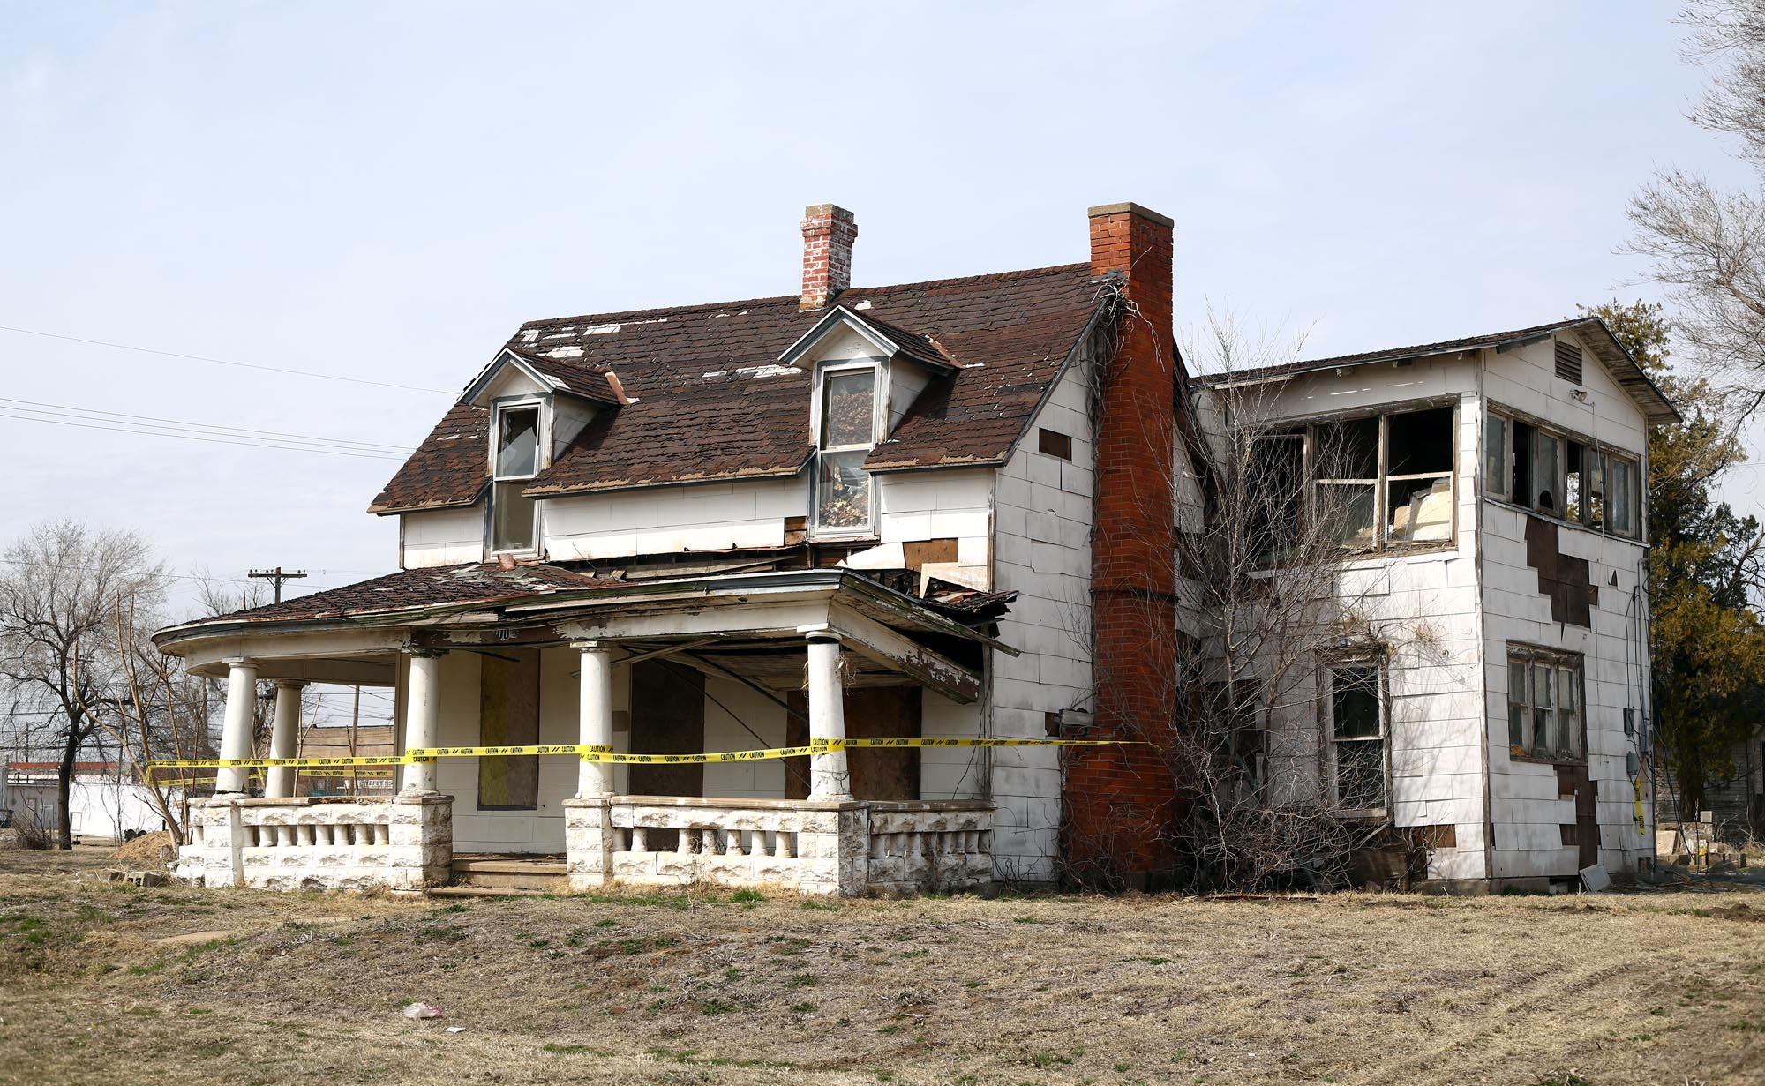

I need to have

I need to have

I will have

windows / exchange

roof / mend

yard/even

facade/insulate

gas installation / screen / replace or fix

foundation of the house/ strengthen

fit / furniture